**USEFUL links 1 – theory**

* In this c shorts—saves time

1]- SQL

<https://cs50.harvard.edu/x/2020/weeks/7/>

2]- flask,ajax

<https://cs50.harvard.edu/x/2021/weeks/9/>

3]- html,css,js

<https://cs50.harvard.edu/x/2021/weeks/8/>

-same thing

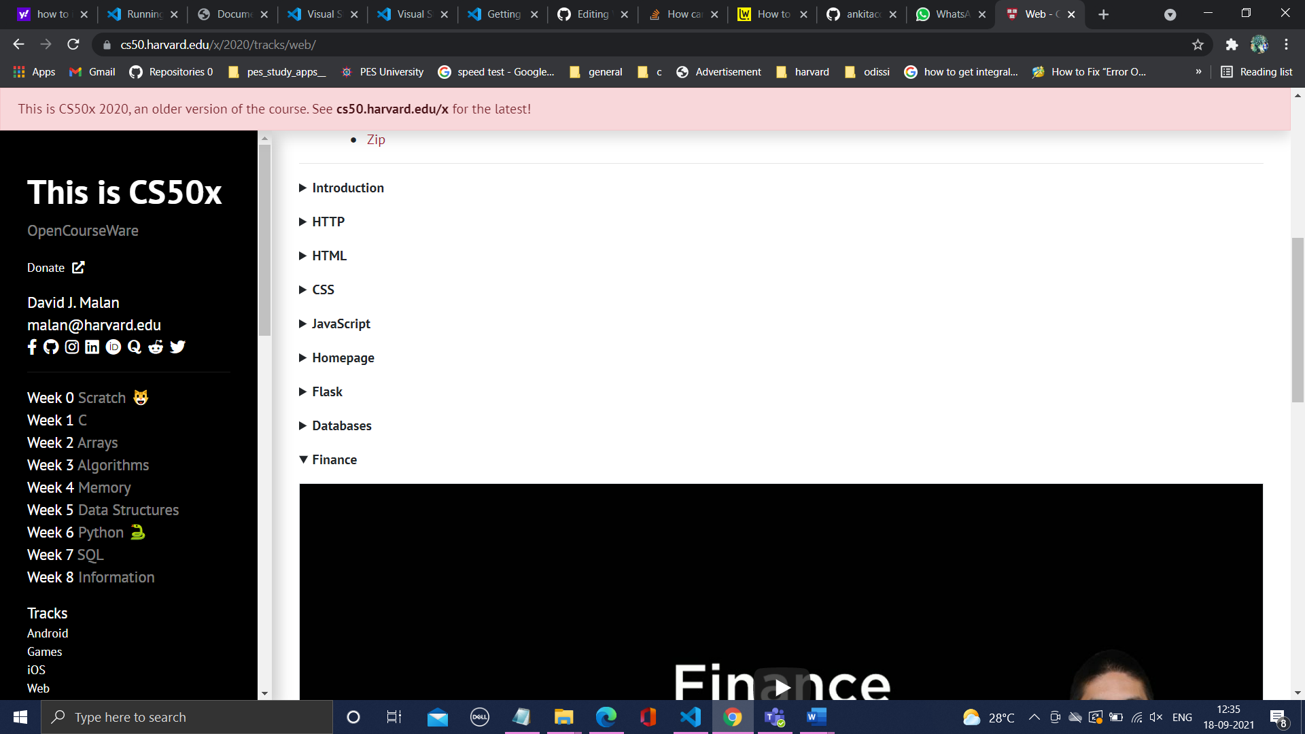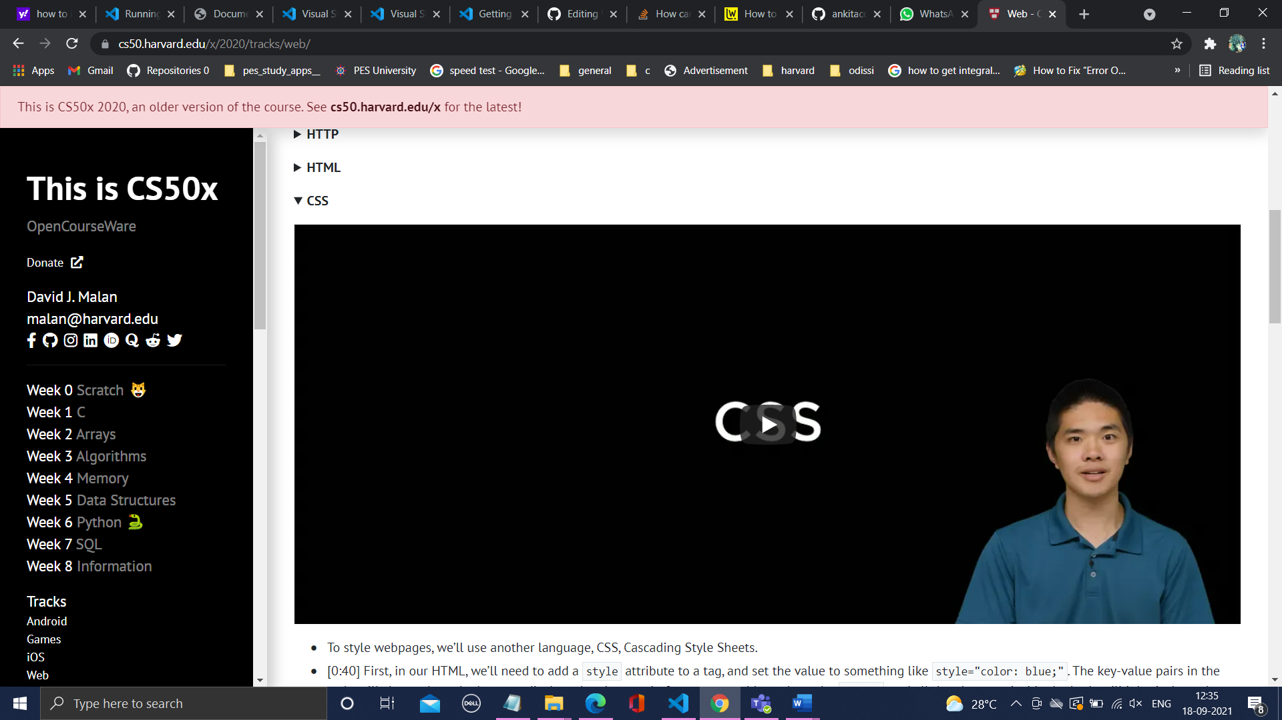

<https://cs50.harvard.edu/x/2020/tracks/web/>

**USEFUL links 1 – more programs**

1]- a program to import student data into a database

<https://cs50.harvard.edu/x/2020/psets/7/houses/>

2]- finance

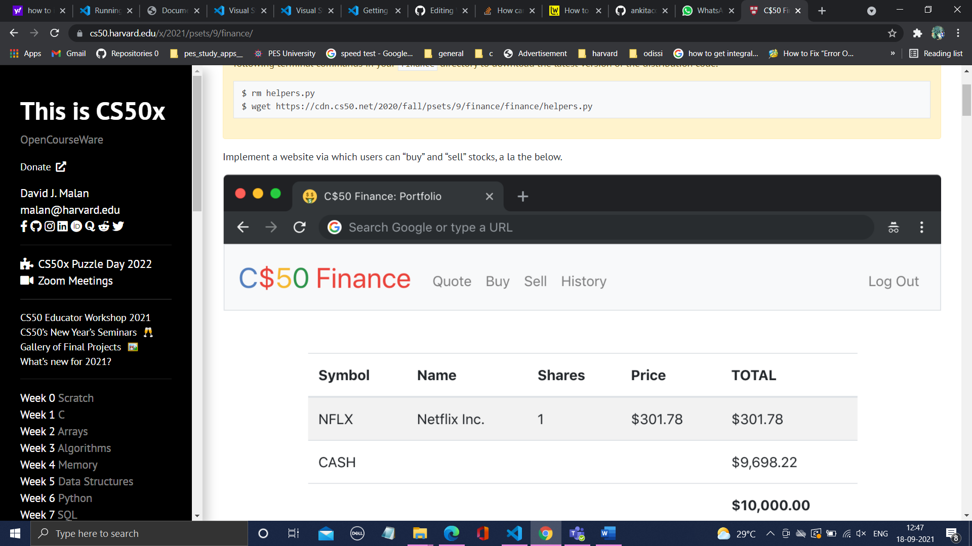

<https://cs50.harvard.edu/x/2021/psets/9/finance/>

3]- birthdays

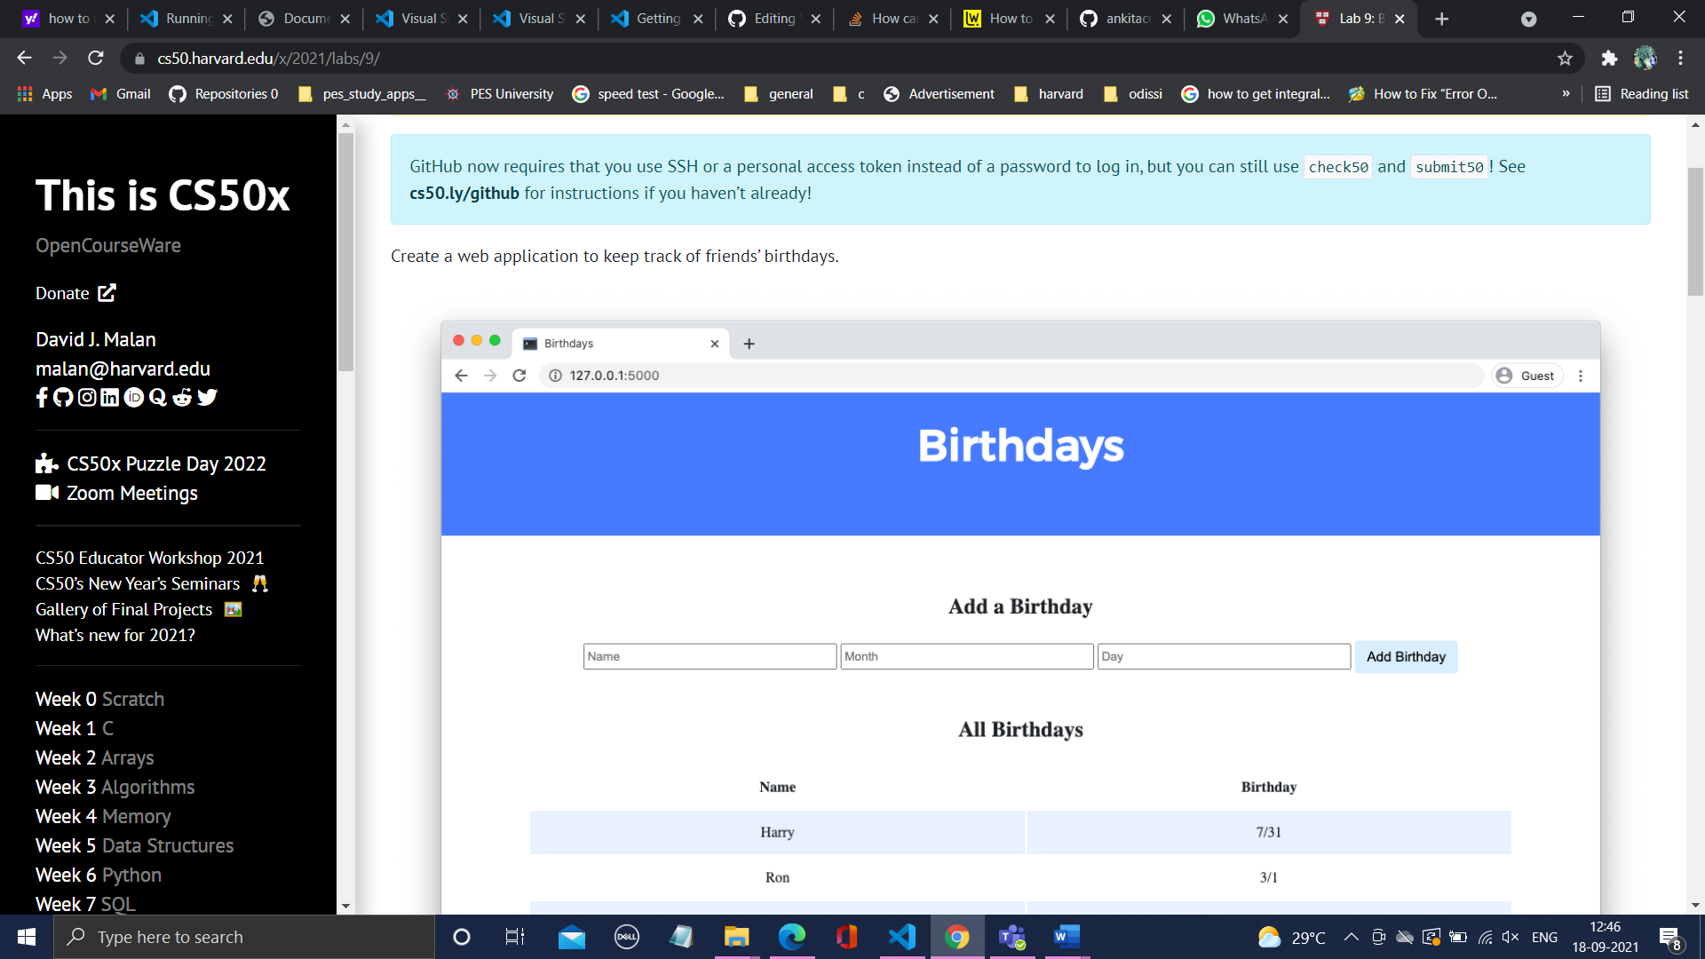

<https://cs50.harvard.edu/x/2021/labs/9/>